|  |  |
| --- | --- |
| **Course:** | **CSE407 Green Computing, Section: 02** |
| **Student ID:** |  |
| **Student Name:** |  |

**Project Title:**

IoT based real-time energy monitoring and dashboard development.

**Checklist:**

* I used IoT technology to monitor the energy consumption of the appliance for a week.
* I have prepared an energy monitoring dashboard/webpage with detailed and summarized information.
* I have considered the financial and business aspects.
* I did PESTLE analysis on the project.

**Declaration**

*I declare that the project was done by myself, and the submitted information is free from any unfair means. I complied with all the relevant legal and organizational requirements.*

|  |  |  |
| --- | --- | --- |
|  | **Signature** |  |
|  | **Name:** |  |
|  | **Date:** |  |

1. **Executive Summary** (1 minute read)

*bla bla bla bla bla bla bla bla bla*

*bla bla bla bla bla bla bla bla bla*

1. **Brief description of the work**

*bla bla bla bla bla bla bla bla bla*

*bla bla bla bla bla bla bla bla bla*

1. **Flowchart of the work**

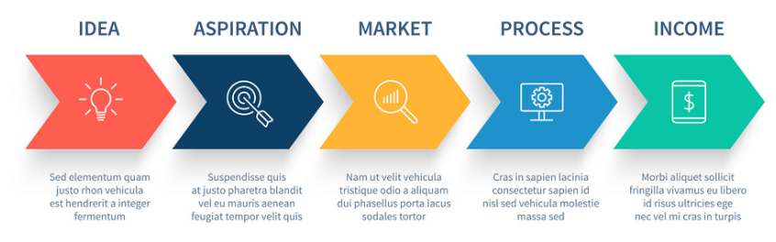

1. **Detailed description of each of the steps [***most detailed section***]**

0. Planning

1. Researching

2. Purchasing

3. Configuration

4. Next steps??

5. After that??

6. Then what??

1. **Challenges and hiccups**

*bla bla bla bla bla bla bla*

*bla bla bla bla bla bla bla*

1. **Demonstration**
   1. Link to energy dashboard: <https://xyz.iot/cse407>
   2. Pictures
2. **Discussion on issues:**
   1. Checklist
   2. Discussion on issues
3. **Appendices**

*codes*

*datasheets*

|  |  |
| --- | --- |
| **Checklist of Issues** ([see explanations here](https://docs.google.com/document/d/1NmOZuItFnxdicnWbEBOf1Es2lHcYfg6IOdwq1hfExPg/edit?usp=sharing)) | **Remarks (if any)** |
| *Planning and researching? |  |
| Data Collected? |  |
| Data Stored? |  |
| Data Displayed in the dashboard? |  |
| *Realtime or stored data? |  |
| *Wattage of the chosen device? |  |
| *Wattage of the measuring equipment? |  |
| *AC Power: Why/not apparent power?  Why/not Instantaneous Power? AC power vs. DC power? |  |
| *Documentation |  |
| *Safety: Electrical Insulation and Isolation? |  |
| *Caution with overclocking/flushing |  |
| *API Issues: Did you get it? How? If not, how did you solve this problem? |  |
| *UI/UX issues?  Standard components of an energy dashboard? |  |
| *User Manual? |  |
| *Future Extensions and Limitations? |  |
| *Installation, Operation and Maintenance? |  |
| *Recurring costs |  |
| *Cost Accounting? |  |
| *Business Aspects? Cost savings and ROI?  Value of this product/service? Justification? |  |
| *Reliability?  Never failed? Any fail-safe mechanisms? |  |
| *Accuracy? Calibration? |  |
| *Data quality?  Sampling rate?  Crosstalk and interference?  Accuracy and calibration? |  |
| *Scalability? |  |
| *Interoperability? |  |
| *Data Security?  Important or not in this case? |  |
| *Compliant with regulations? |  |
| *Environmental Impacts?  PESTLE analysis? |  |